**LAB PRACTICAL**

**TASK-1:** Create a program to show implicit intent.

**MainActivity.java –**

package com.example.app2;  
import androidx.appcompat.app.AppCompatActivity;  
import android.content.Intent;  
import android.net.Uri;  
import android.os.Bundle;  
import android.view.View;  
import android.widget.Button;  
import android.widget.EditText;  
public class MainActivity extends AppCompatActivity {  
 EditText e1;  
 Button bt1;  
 @Override  
 protected void onCreate(Bundle savedInstanceState) {  
 super.onCreate(savedInstanceState);  
 setContentView(R.layout.*activity_main*);  
 e1=findViewById(R.id.*et1*);  
 bt1=findViewById(R.id.*b1*);  
 bt1.setOnClickListener(new View.OnClickListener() {  
 @Override  
 public void onClick(View view) {  
 String url=e1.getText().toString();  
 Intent in=new Intent(Intent.*ACTION_VIEW*, Uri.*parse*(url));  
 startActivity(in);  
 }  
 });  
 }  
}

**activity_main.xml –**

<?xml version="1.0" encoding="utf-8"?>  
<RelativeLayout xmlns:android="http://schemas.android.com/apk/res/android"  
 xmlns:app="http://schemas.android.com/apk/res-auto"  
 xmlns:tools="http://schemas.android.com/tools"  
 android:layout_width="match_parent"  
 android:layout_height="match_parent"  
 tools:context=".MainActivity">  
 <EditText  
 android:id="@+id/et1"  
 android:layout_width="match_parent"  
 android:layout_height="wrap_content"  
 android:layout_marginStart="@android:dimen/app_icon_size"  
 android:layout_marginTop="@android:dimen/app_icon_size"  
 android:layout_marginEnd="@android:dimen/app_icon_size"  
 android:layout_marginBottom="@android:dimen/app_icon_size"/>  
 <Button  
 android:layout_width="match_parent"  
 android:layout_height="wrap_content"  
 android:layout_below="@+id/et1"  
 android:id="@+id/b1"  
 android:text="VISIT"  
 android:textSize="20dp"  
 android:textStyle="bold" />

</RelativeLayout>

**OUTPUT** –

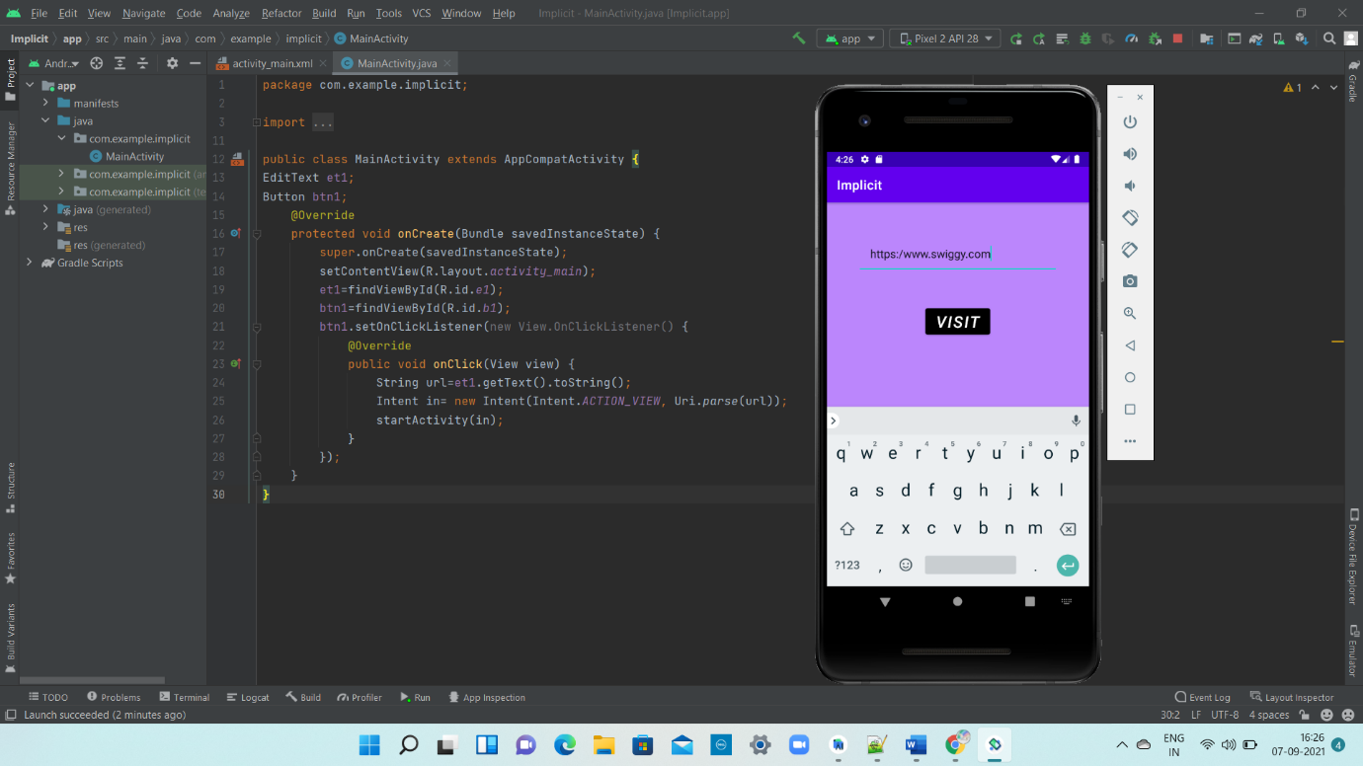 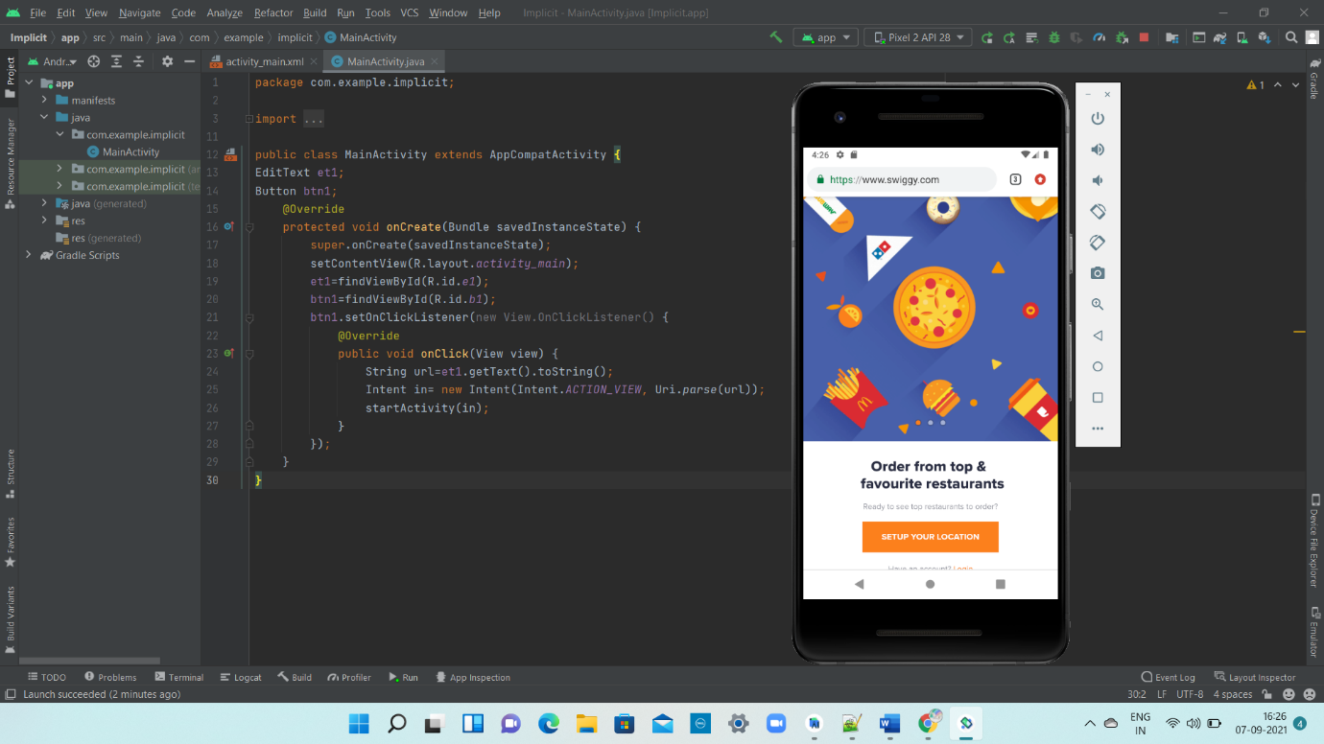

**TASK-2**: Create a program to show explicit intent

**MAIN_ACTIVITY -1 code :**

<?xml version="1.0" encoding="utf-8"?>  
<RelativeLayout xmlns:android="http://schemas.android.com/apk/res/android" xmlns:app="http://schemas.android.com/apk/res-auto" xmlns:tools="http://schemas.android.com/tools"  
 android:layout_width="match_parent"  
 android:layout_height="match_parent"  
 tools:context=".MainActivity">  
 <TextView  
 android:layout_width="match_parent"  
 android:layout_height="wrap_content"  
 android:text="Hello, This is Activity1"  
 android:gravity="center"  
 android:layout_marginTop="90dp"  
 android:textSize="40dp"  
 android:textColor="@color/teal_200"  
 android:textStyle="bold" android:id="@+id/tv_1"/>  
 <Button  
 android:layout_width="wrap_content"  
 android:layout_height="wrap_content"  
 android:layout_below="@+id/tv_1"  
 android:layout_marginTop="60dp"  
 android:id="@+id/btn1"  
 android:layout_centerHorizontal="true"  
 android:text="Click Here for Activity2"/>  
</RelativeLayout>

JAVA CODE:

package com.example.explicit_intent;   
import androidx.appcompat.app.AppCompatActivity;   
import android.content.Intent;   
import android.os.Bundle;   
import android.view.View;   
import android.widget.Button;  
import android.widget.TextView;   
public class MainActivity extends AppCompatActivity {   
 TextView tv; Button btn;   
 @Override   
 protected void onCreate(Bundle savedInstanceState) {   
 super.onCreate(savedInstanceState);   
 setContentView(R.layout.activity_main);   
 tv=findViewById(R.id.tv_1);   
 btn=findViewById(R.id.btn1);   
 btn.setOnClickListener(new View.OnClickListener() {   
 @Override   
 public void onClick(View v) {   
 Intent i=new Intent(getApplicationContext(),Activity2.class);   
 startActivity(i);   
 }   
 });   
 }  
}

MAIN_ACTIVITY-2 CODE:

<?xml version="1.0" encoding="utf-8"?>   
<RelativeLayout   
 xmlns:android="http://schemas.android.com/apk/res/android" xmlns:app="http://schemas.android.com/apk/res-auto"   
 xmlns:tools="http://schemas.android.com/tools"   
 android:layout_width="match_parent"   
 android:layout_height="match_parent"   
 tools:context=".Activity2">   
 <TextView   
 android:layout_width="match_parent"   
 android:layout_height="wrap_content"   
 android:text="Hello This is Activity2"   
 android:textSize="40dp"   
 android:layout_centerHorizontal="true"   
 android:layout_centerVertical="true"   
 android:textColor="@color/teal_200"/>   
</RelativeLayout>

OUTPUT:

